

CAR RENTAL FLEET MANAGER
JAVA PROJECT

K. HARINI
2620030026
SECTION - 13

CAR RENTAL FLEET MANAGER

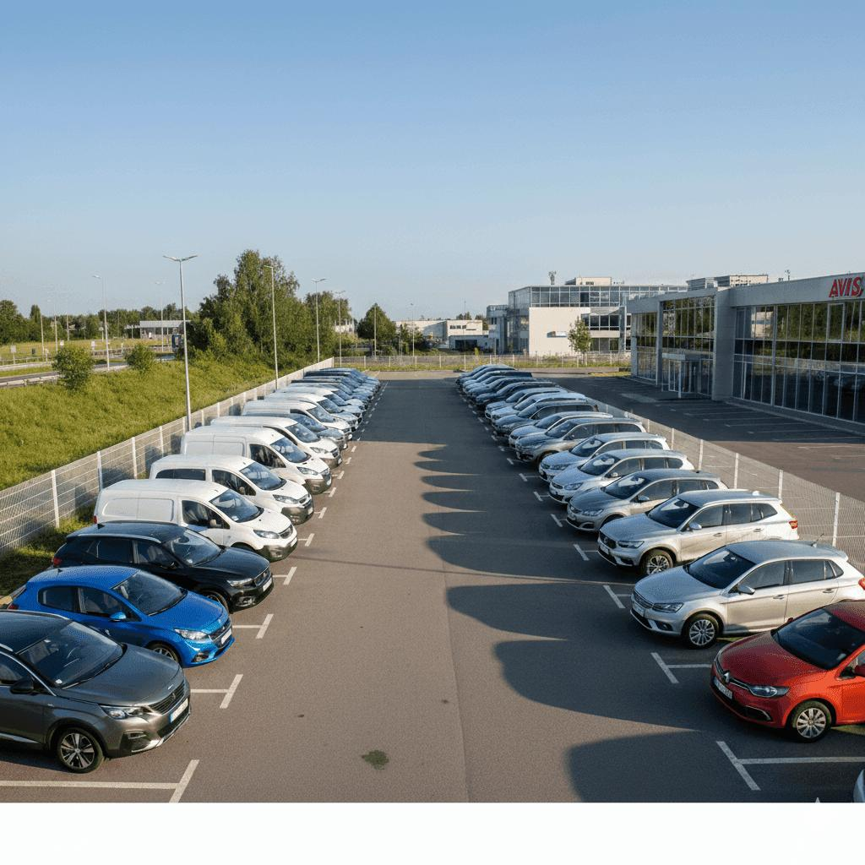

ABSTRACT
The Car Rental Fleet Manager is a Java-based application developed to handle the tasks of a car rental business. The system keeps track of details about cars, people who rent them how long they are rented how many miles are driven how much fuel is used, the cost of renting and when cars need maintenance.
The project is built step by step using the Java programming ideas taught in each Course Outcome. CO1 sets up the structure of the project. CO2 adds choices and repeated actions using control-flow statements. CO3 makes the system better, by using functions, recursion and arrays.
This project shows how a real-life problem can be turned into a organized Java application one step at a time.

ADVANTAGES
- Helps manage car rental information systematically.
- Reduces manual calculation of rental charges.
- Maintains vehicle and customer details.
- Calculates rental charges based on rental duration and mileage.
- Checks vehicle availability.
- Helps identify vehicles requiring service.
- Makes repeated rental operations easier to manage.
- Demonstrates practical application of Java programming concepts.
- Can be extended with additional features in the future

IMPLEMENTATION OF CODE

CO-WISE IMPLEMENTATION

In CO1, we create the basic version of the Car Rental Fleet Manager. It accepts one vehicle's rental details and calculates the total rental charge.

CODE

import java.util.Scanner;
public class CarFleetManagerCO1 {
public static void main(String[] args) {
Scanner sc = new Scanner(System.in);
String customerName;
String vehicleId;
String vehicleClass;
int rentalDays;
double dailyRate;
double distanceTravelled;
double ratePerKm;
double fuelCharge;

System.out.println("===== CAR RENTAL FLEET MANAGER =====");
System.out.print("Enter Customer Name: ");
customerName = sc.nextLine();
System.out.print("Enter Vehicle ID: ");
vehicleId = sc.nextLine();
System.out.print("Enter Vehicle Class: ");
vehicleClass = sc.nextLine();
System.out.print("Enter Number of Rental Days: ");
rentalDays = sc.nextInt();
System.out.print("Enter Daily Rental Rate: ");
dailyRate = sc.nextDouble();
System.out.print("Enter Distance Travelled (km): ");
distanceTravelled = sc.nextDouble();
System.out.print("Enter Rate Per Km: "
ratePerKm = sc.nextDouble();
System.out.print("Enter Fuel Charge: ");
fuelCharge = sc.nextDouble();
double rentalCharge = rentalDays * dailyRate;
double mileageCharge =
distanceTravelled * ratePerKm;
double totalCharge =
rentalCharge + mileageCharge + fuelCharge;

System.out.println("\n===== RENTAL DETAILS =====");
System.out.println("Customer Name: " + customerName);
System.out.println("Vehicle ID: " + vehicleId);
System.out.println("Vehicle Class: " + vehicleClass);
System.out.println("Rental Days: " + rentalDays);
System.out.println("Daily Rate: Rs." + dailyRate);
System.out.println("Distance: " + distanceTravelled + " km");
System.out.println("Rental Charge: Rs." + rentalCharge);
System.out.println("Mileage Charge: Rs." + mileageCharge);
System.out.println("Fuel Charge: Rs." + fuelCharge);
System.out.println("----------------------------");
System.out.println("Total Charge: Rs." + totalCharge);
sc.close();
}
}

OUTPUT
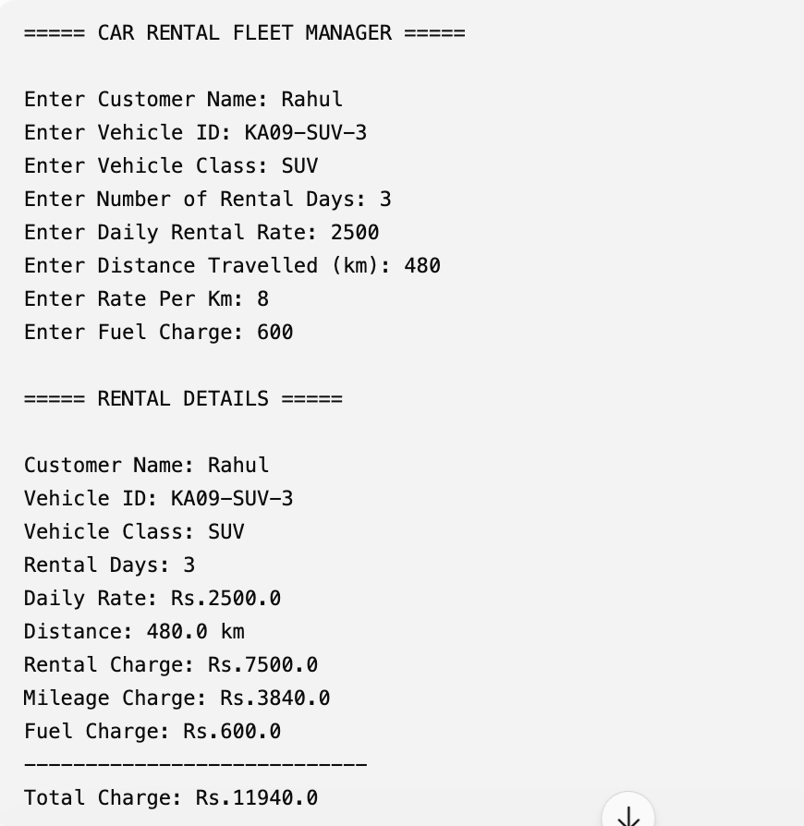

In CO2, we improve the Car Rental Fleet Manager by adding:
- Vehicle class selection
- Availability checking
- Service checking
- Rental charge calculation
- Multiple operations Menu-driven system
Here we use selection and iteration.

CODE

import java.util.Scanner;
public class CarFleetManagerCO2 {
public static void main(String[] args) {
Scanner sc = new Scanner(System.in);
int choice;
do {
System.out.println("\n===== CAR RENTAL FLEET MANAGER =====");
System.out.println("1. Rent a Car");
System.out.println("2. Check Vehicle");
System.out.println("3. Calculate Rental Charge");
System.out.println("4. Display Vehicle Classes");
System.out.println("5. Exit");
System.out.print("Enter your choice: ");
choice = sc.nextInt();
switch (choice) {
case 1:
System.out.println("\n--- RENT A CAR ---");
System.out.print("Enter vehicle ID: ");
String vehicleId = sc.next();
System.out.println("Vehicle Classes:");
System.out.println("1. Economy");
System.out.println("2. SUV");
System.out.println("3. Luxury");
System.out.print("Choose class: ");
int vehicleChoice = sc.nextInt();

String vehicleClass;
double dailyRate;
if (vehicleChoice == 1) {
vehicleClass = "Economy";
dailyRate = 1500;
} else if (vehicleChoice == 2) {
vehicleClass = "SUV";
dailyRate = 2500;
} else if (vehicleChoice == 3) {
vehicleClass = "Luxury";
dailyRate = 5000;
} else {
System.out.println("Invalid vehicle class.");
break;
}
System.out.print("Enter rental days: ");
int days = sc.nextInt();
if (days <= 0) {
System.out.println("Invalid number of days.");
} else {
double charge = days * dailyRate;
System.out.println("\nRental Successful");
System.out.println("Vehicle ID: " + vehicleId);
System.out.println("Class: " + vehicleClass);
System.out.println("Days: " + days);
System.out.println("Total Charge: Rs." + charge);
}
break;
case 2:
System.out.println("\n--- CHECK VEHICLE ---");
System.out.print("Enter current odometer: ");
double odometer = sc.nextDouble();
if (odometer >= 40000) {
System.out.println(
"Vehicle requires service.");
System.out.println(
"Rental is BLOCKED.");
} else

{
System.out.println(
"Vehicle is available for rental.");
}
break;
case 3:
System.out.println("\n--- RENTAL CHARGE ---");
System.out.print("Enter rental days: ");
int rentalDays = sc.nextInt();
System.out.print("Enter daily rate: ");
double rate = sc.nextDouble();
System.out.print("Enter distance travelled: ");
double distance = sc.nextDouble();
System.out.print("Enter rate per km: ");
double kmRate = sc.nextDouble();
double baseCharge =
rentalDays * rate;
double mileageCharge =
distance * kmRate;
double total =
baseCharge + mileageCharge;
System.out.println(
"Base Charge: Rs." + baseCharge);
System.out.println(
"Mileage Charge: Rs." + mileageCharge);
System.out.println(
"Total Charge: Rs." + total);
break;
case 4:
System.out.println ("\n--- VEHICLE CLASSES ---");
System.out.println("1. Economy - Rs.1500/day");
System.out.println("2. SUV - Rs.2500/day");
System.out.println( "3. Luxury - Rs.5000/day");
break;
case 5:
System.out.println( "Thank you for using the system.");
break;

default:
System.out.println(
"Invalid choice.");
}
} while (choice != 5);
sc.close();
}
}

OUTPUT

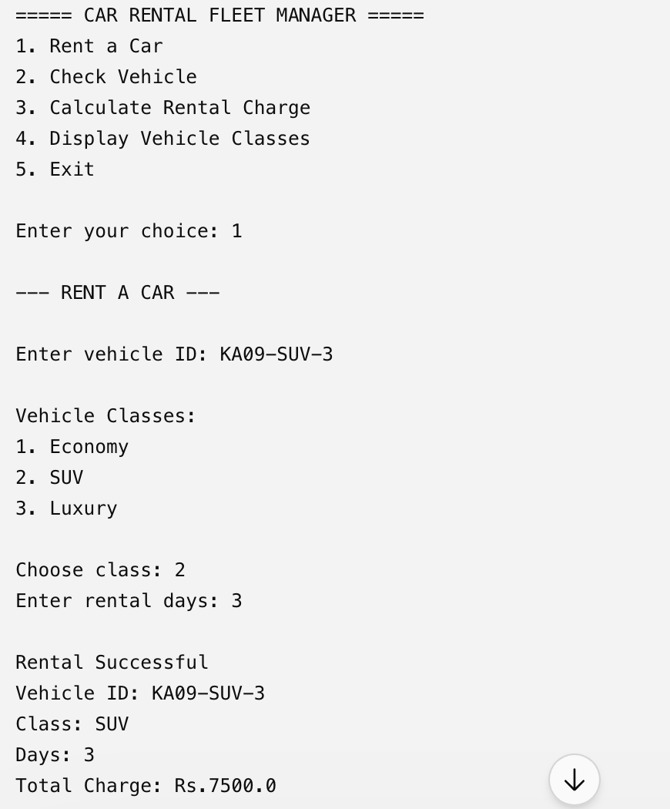
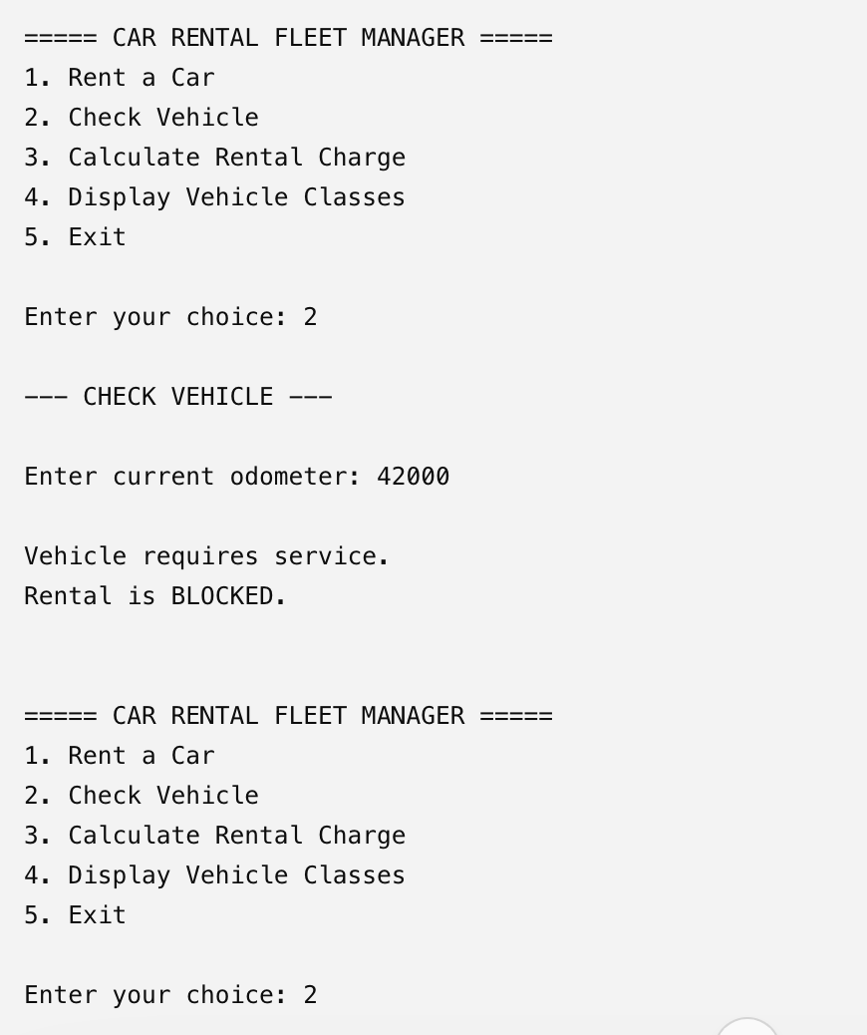
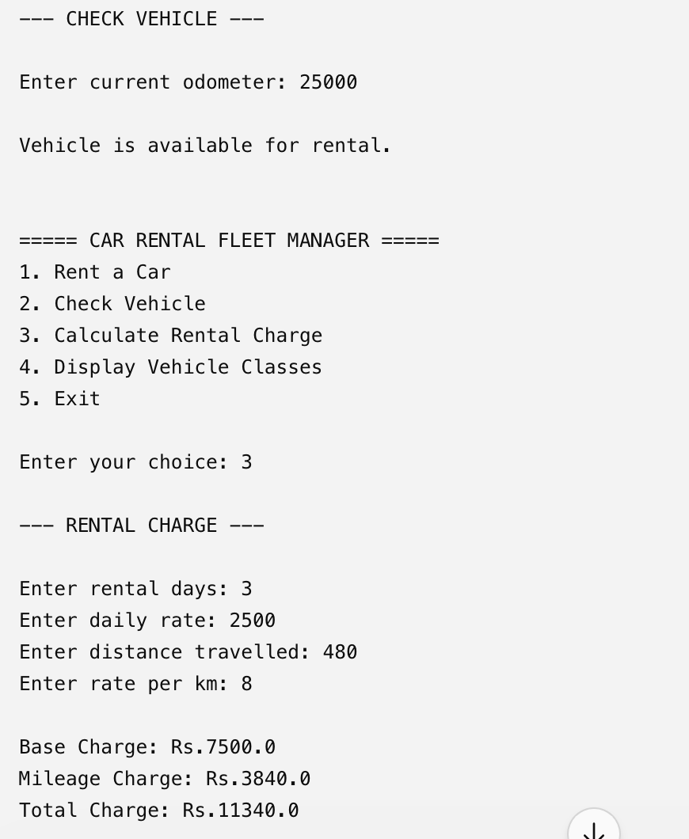
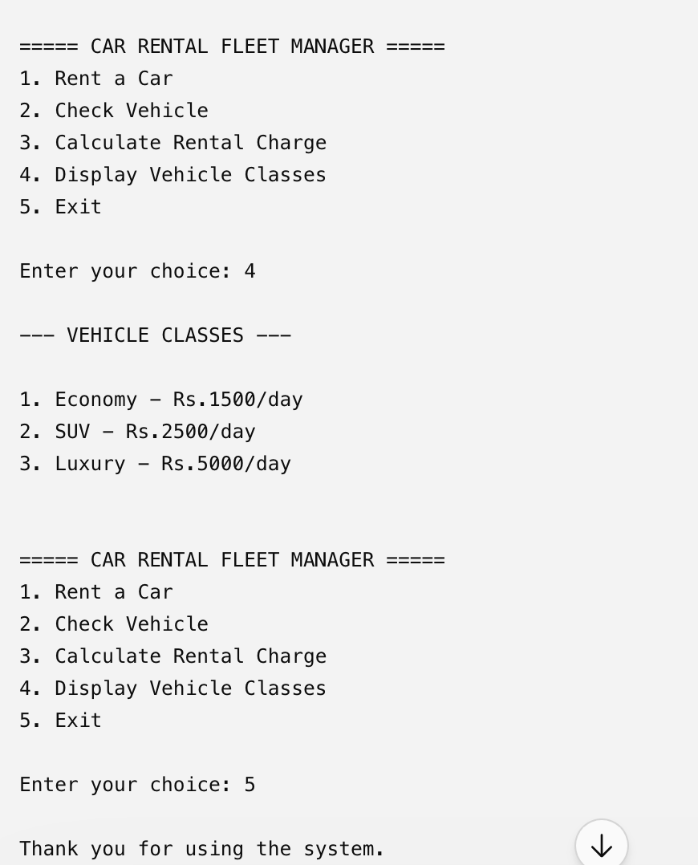

In CO3, the project is expanded to manage multiple vehicles instead of only one vehicle.
The program uses:
- Methods for separate operations
- 1-D arrays for vehicle information
- 2-D arrays for rental records
- Recursion for displaying vehicle information
CODE

import java.util.Scanner;
public class CarFleetManagerCO3 {
static Scanner sc = new Scanner(System.in);
static String[] vehicleId = {
"KA01-ECO-1",
"KA09-SUV-3",
"KA05-LUX-7"
};
static String[] vehicleClass =
{
"Economy",
"SUV",
"Luxury"
};

static double[] dailyRate =
{
1500,
2500,
500 };

static double[] odometer = {
20000,
39000,
15000
};

static int[][] rentalData = new int[3][2];
static void displayVehicle(int index) {
System.out.println( "Vehicle ID: " + vehicleId[index]);
System.out.println( "Class: " + vehicleClass[index]);
System.out.println( "Daily Rate: Rs." + dailyRate[index]);
System.out.println( "Odometer: " + odometer[index] + " km");
System.out.println();
}
static void displayVehicles(int index) {
if (index == vehicleId.length) {
return;
}
displayVehicle(index);
displayVehicles(index + 1);
}
static double calculateCharge(
int days,
double rate,
double distance,
double kmRate) {
double baseCharge = days * rate;
double mileageCharge =
distance * kmRate;

return baseCharge + mileageCharge;
}
static int searchVehicle(String id) {
for (int i = 0; i < vehicleId.length; i++) {
if (vehicleId[i].equalsIgnoreCase(id)) {
return i;
}
}
return -1;
}
static void showFleet() {
System.out.println("\n===== VEHICLE FLEET =====");
displayVehicles(0);
}
public static void main(String[] args) {
int choice;
do {
System.out.println(
"\n===== CAR RENTAL FLEET MANAGER =====");
System.out.println("1. Display Fleet");
System.out.println("2. Search Vehicle");
System.out.println("3. Rent Vehicle");
System.out.println("4. Display Rental Data");
System.out.println("5. Exit");
System.out.print("Enter choice: ");
choice = sc.nextInt();
switch (choice) {
case 1:
showFleet();
break;

case 2:
System.out.print( "Enter vehicle ID: ");
String id = sc.next();
int index = searchVehicle(id);
if (index == -1) {
System.out.println("Vehicle not found.");
} else {
displayVehicle(index);
}
break;
case 3:
System.out.print( "Enter vehicle number (1-3): ");
int vehicleNumber = sc.nextInt();
if (vehicleNumber < 1 || vehicleNumber > 3) {
System.out.println( "Invalid vehicle.");
break;
}
int vehicleIndex = vehicleNumber - 1;
System.out.print( "Enter rental days: ");
int days = sc.nextInt();
System.out.print( "Enter distance travelled: ");
double distance = sc.nextDouble();
double kmRate;
if (vehicleClass[vehicleIndex]
.equals("Economy")) {
kmRate = 5;
} else if (
vehicleClass[vehicleIndex]
.equals("SUV")) {
kmRate = 8;

} else {
kmRate = 12;
}
double charge =
calculateCharge(
days,
dailyRate[vehicleIndex],
distance,
kmRate);

rentalData[vehicleIndex][0] = days;
rentalData[vehicleIndex][1] = (int) distance;

System.out.println( "\nRental Successful");
System.out.println( "Vehicle: + vehicleId[vehicleIndex]);
System.out.println("Class: + vehicleClass[vehicleIndex]);
System.out.println(
"Total Charge: Rs."
+ charge);
break;
case 4:
System.out.println("\n===== RENTAL DATA =====");
for (int i = 0;
i < rentalData.length;
i++) {
System.out.println(vehicleId[i]);
System.out.println("Rental Days: "+ rentalData[i][0]);
System.out.println(
"Distance: "
+ rentalData[i][1] + " km");

System.out.println();
}
break;
case 5:
System.out.println("Thank you!");
break;
default:
System.out.println(“Invalid choice.")
}
} while (choice != 5);
sc.close();
}
}

OUTPUT
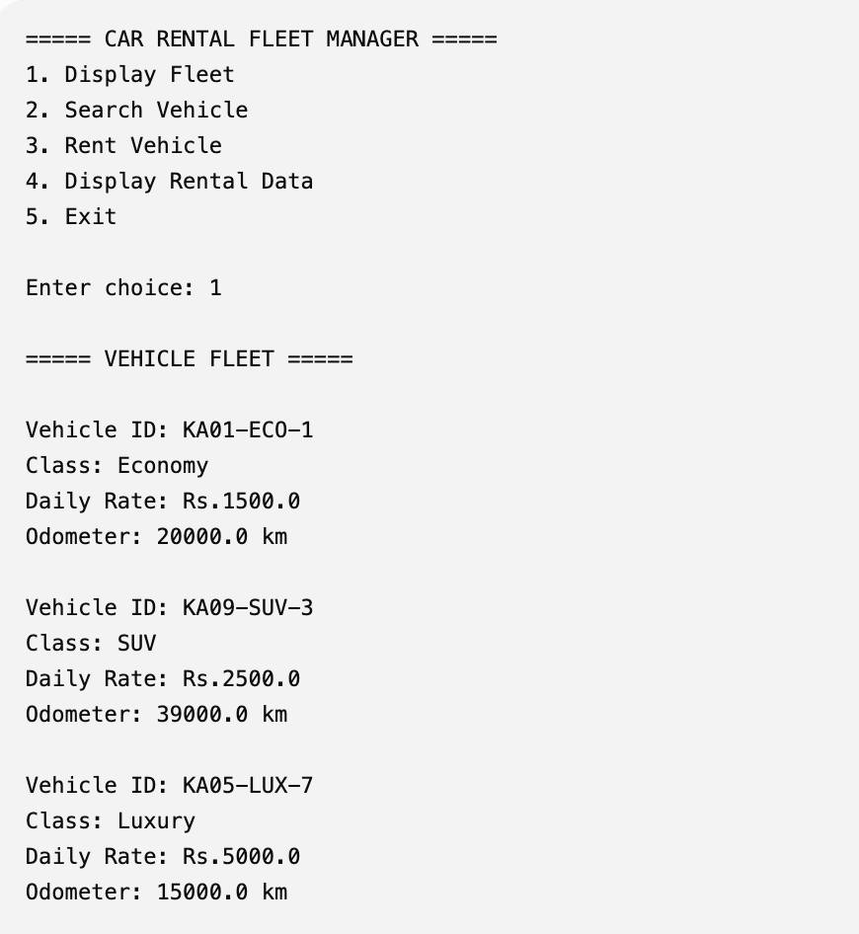

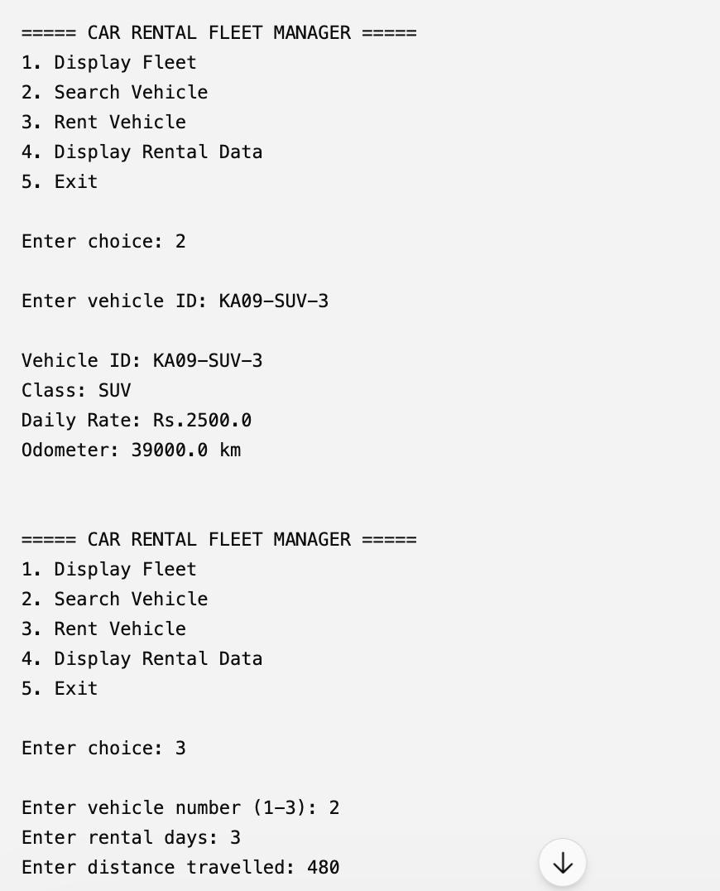
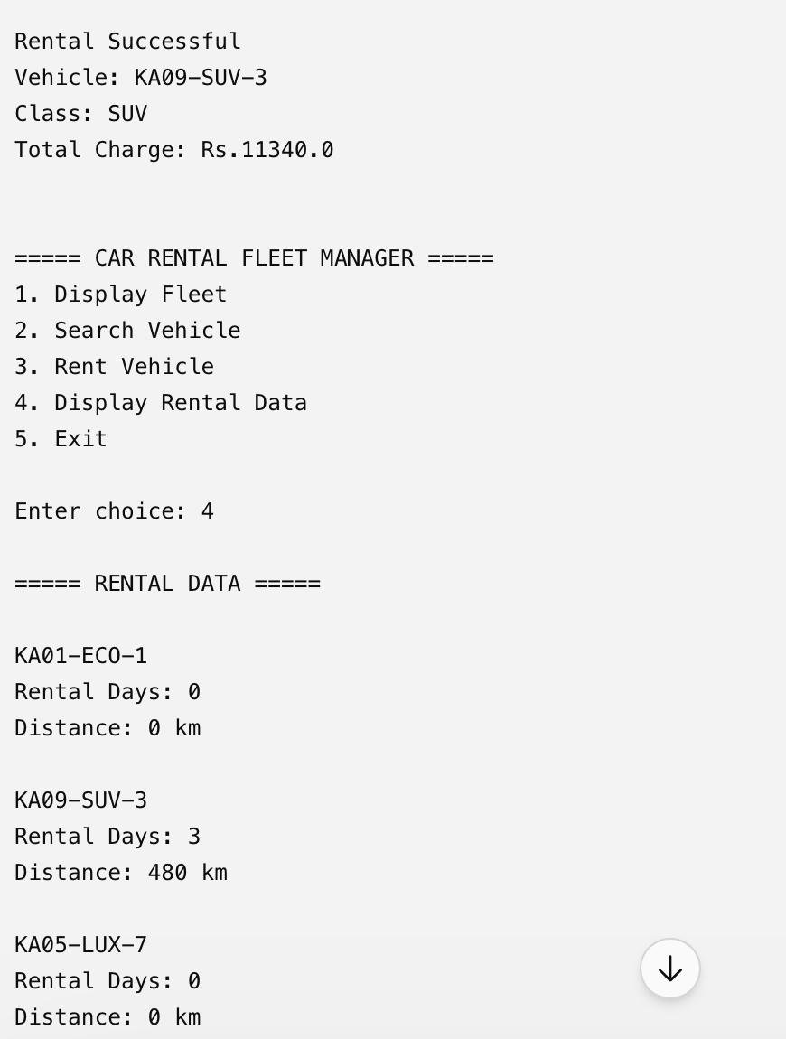
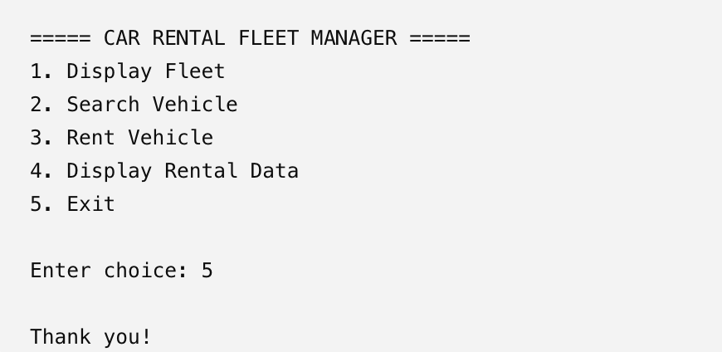

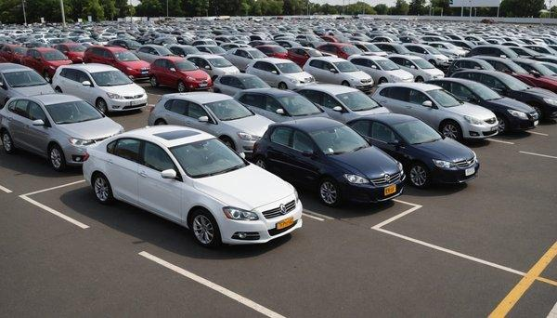

CONCLUSION
The Car Rental Fleet Manager project shows step-by-step how to build a Java application. The Car Rental Fleet Manager project starts with programming ideas in CO1 then moves to decision making and loops in CO2 and finally extends the app with methods, recursion and arrays in CO3.

The Car Rental Fleet Manager project demonstrates how each programming concept can be used one after another to solve a real car-rental problem. The Car Rental Fleet Manager project gives a base for future upgrades such, as file handling, object-oriented design, database connections and graphical user interfaces.

